MODULE: 11 | LESSON: 4 | WRITING INEQUALITIES

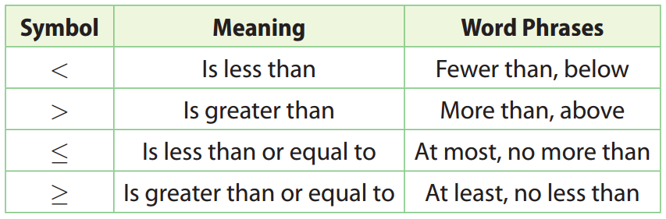

Inequality | Meaning | Solution of Inequality
x > 3 | All numbers greater than 3 | The open circle at 3 shows that the value 3 is not included in the solution.
x ≥ 3 | All numbers greater  than or equal to 3 | The closed circle at 3 shows that the value 3 is included in the solution.
x < 3 | All numbers less than 3
x ≤ 3 | All numbers less than or equal to 3

